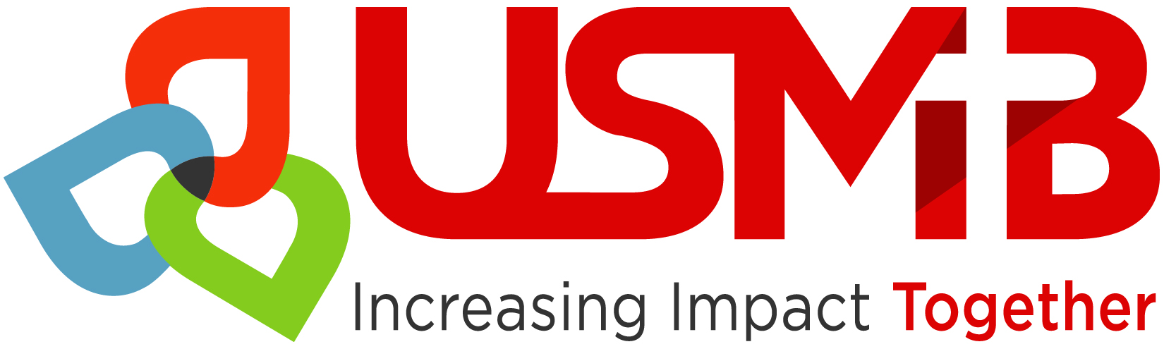

USMB
Membership/Affiliation Covenant

We agree to the following as it concerns our involvement with the U.S. Conference of Mennonite Brethren Churches and the appropriate District Conference of Mennonite Brethren Churches.

We commit ourselves to abide by the Bylaws of both the District and USMB.

- Our church will consider ourselves to be a Mennonite Brethren Church in all respects, including our church’s actions, teachings and ministries.

- Our church will respect the Confession of Faith of the Mennonite Brethren Church and will participate in the community dialogue which shapes our beliefs.

- We will include reference of our affiliation/membership with the MB Conference of Churches in our church by-laws and/or church constitution.

- Our church will participate regularly in the conventions, conferences, missions, and programs of the USMB and of our District Conference.

- We commit to providing regular conference financial support in the future, to both the USMB and our District Conference.

- We will educate ourselves concerning the Mennonite Brethren Mission, Vision, and Core Values.

- We commit to staying informed about and being involved in the future vision of the US Conference of MB Churches in the U.S.

Signed:

______________________________________ ________________
(Pastor) (Date)

______________________________________________ ___________________
(Church Leader) (Date)

09/2017

