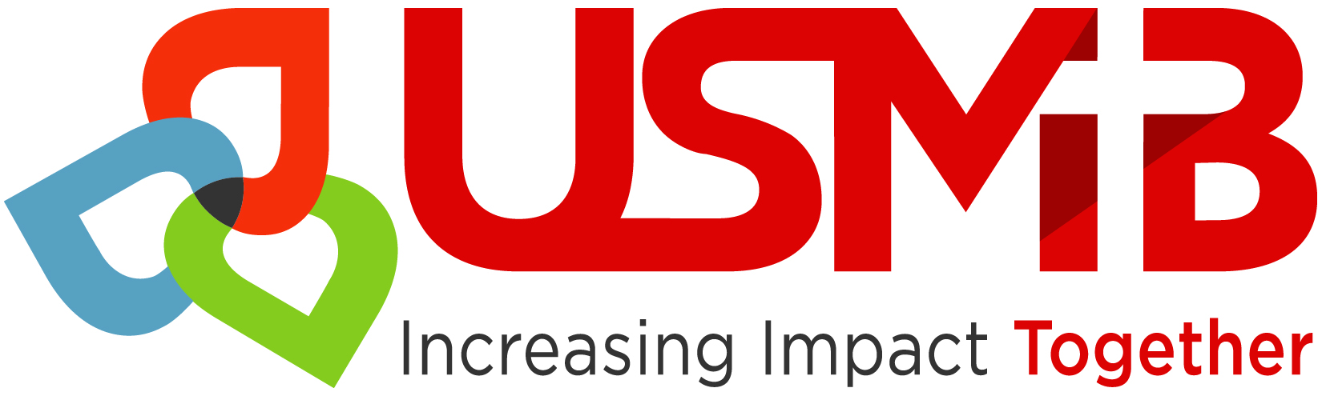
U.S. Conference of Mennonite Brethren Churches
CHURCH APPLICATION
FOR MEMBERSHIP
CHURCH APPLICATION FOR MEMBERSHIP
PLEASE SEND TO THE DISTRICT TO WHICH YOU ARE APPLYING:

United States Conference of Mennonite Brethren Churches
7348 W 21st Suite 115, Wichita, KS 67205 offices@usmb.org

National Director: Don Morris
1433 NW 150th St. Edmond, OK 73013 don@usmb.org

DISTRICT MINISTERS:

Central District Conference: Rick Eshbaugh reshbaugh@msn.com
1106 N. Garfield Ave. Dell Rapids, SD 57022

Latin America District Conference: Aaron Hernandez aronmasale@yahoo.com
PO Box 52, La Grulla, TX 78548

Eastern District Conference: Terry Hunt
PO Box 2697, Lenoir, NC 28645 pastortwh@gmail.com

Pacific District Conference: Dennis Fast (Interim)
1717 S. Chestnut Ave. Fresno, CA 93702-4709 dennis.fast@fresno.edu

Southern District Conference: Tim Sullivan
7348 W. 21st St., Suite 115, Wichita, KS 67205-1765 tsully@sdcmb.org
U.S. Conference of Mennonite Brethren Churches

Legal Name of Church
Address
City, State, Zip
Phone
Church website
Church FEIN
Name of Pastor
Pastor’s contact information:
Address
City, State, Zip
Cell
Email
Church’s current denominational affiliation (if any)

Please answer the following questions:

- Describe the history of the church (how and when did the church begin, important events/transitions in the life of the congregation, etc.)

- What has attracted you to the Mennonite Brethren?

- Have you read the USMB Confession of faith and National and District bylaws and affirm them?

- Has your pastor completed the ministry questionnaire for licensure? If not, what is the anticipated date of completion?

- Has your pastor read and signed the Pastoral Covenant?

- Describe the church facilities (buildings, seating capacity, own, rent, mortgage loan)?

- What is the average Sunday morning worship attendance? Of this number, how many are children/youth (under 18)?

- What language is spoken in worship?

- What are the main ministries of the church?

- What is the annual budget (total amount given per year)?

- Depending on your church governance model, has the congregational body entrusted with decision making voted in favor of joining the Mennonite Brethren Conference? Yes No

What was the date of the vote?

The total number of votes:

- Please attach a copy of the church bylaws.

AGREEMENT

If accepted into the Mennonite Brethren Conference, we agree:

- To work in harmony with and contribute to the ministry of the USMB and District Conferences of Mennonite Brethren Churches.

- To amend the by-laws of our church by adding a declaration of affiliation with the (Pacific, Southern, Central, North Carolina or LAMB) District Conference of Mennonite Brethren Churches.

- To include in the official corporate name of the church the words: “Mennonite Brethren Church” (this need not be included in the published or “street” name of the church).

Date and Sign:

Chair

Secretary

Pastor

